***Project Documentation Report***

***1. Introduction:***

*The Farewell Party Management System is a comprehensive platform designed to simplify the organization process for junior students planning a memorable farewell event for their senior counterparts. This system aims to streamline event planning while facilitating the participation of teachers and their families. The objective is to create a wholesome experience covering attendee management, task assignments, budget tracking, and detailed planning of various aspects of the event.*

***2. System Overview:***

*The system encompasses various modules and functionalities to address different aspects of organizing a farewell party. These modules include:*

***Student Registration/Login***

***Menu Suggestions***

***Performance Volunteer***

***Teachers and Family Registration***

***Task Allocation***

***Attendance Tracking***

***Role-Based Use Cases***

***3. ERD (Entity-Relationship Diagram):***

*The ERD visually represents the entities and their relationships within the Farewell Party Management System. It outlines the structure of the database and the associations between different data entities.*

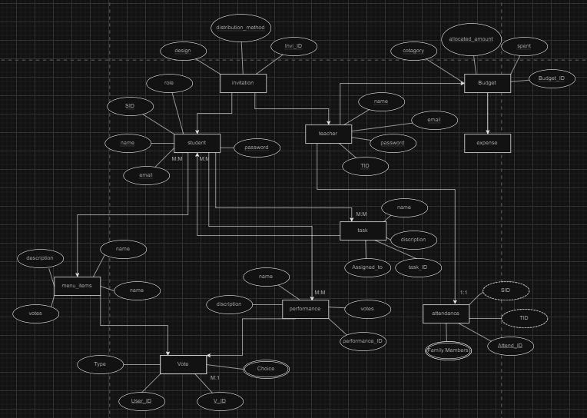

***4. Relational Schema:***

*The relational schema maps the ERD to a database design, specifying tables, attributes, and relationships. It serves as a blueprint for implementing the database schema in MySQL.*

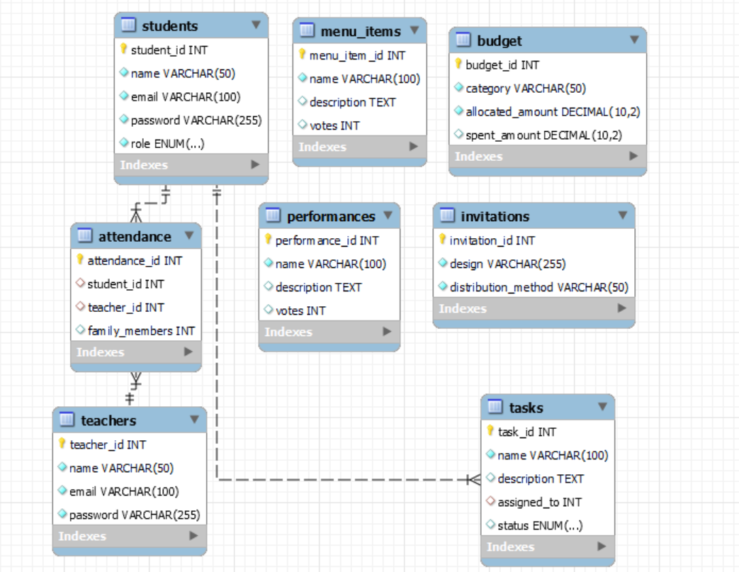

***5. Database Design:***

*The database design is implemented using MySQL, with tables created according to the relational schema. It includes tables for student information, menu suggestions, performances, task assignments, attendance tracking, budget management, and other relevant entities.*

***6. System Functionality:***

*Student Registration/Login: Allows new and returning students to register for the farewell party and access their accounts securely.*

*Menu Suggestions: Enables students to suggest items for the dinner menu and vote for their preferred options.*

*Performance Volunteer: Allows students to propose stage performances and participate in voting for selected performances.*

*Teachers and Family Registration: Facilitates teachers' registration for the event and captures details about accompanying family members.*

*Task Allocation: Enables organizers to assign tasks to student volunteers and track task completion status.*

*Attendance Tracking: Allows system administrators to monitor attendance and generate attendance reports.*

*Budget Tracking: Provides a budget tracking system to monitor event expenses and update budget status.*

***7. Role-Based Use Cases:***

*The system includes role-based use cases for senior students, managers of different teams (e.g., dinner menu team, performance team), budget manager, and task assignment managers. These use cases outline specific functionalities and interactions tailored to each role.*

***8. Implementation****:*

*The system is implemented using HTML, CSS, JavaScript, Node.js, and MySQL. User-friendly interfaces are designed to capture and display relevant information, while MySQL is used for seamless data integration and storage.*

***9. Conclusion:***

*The Farewell Party Management System provides a comprehensive solution for organizing farewell events, ensuring a memorable experience for all participants. With its user-friendly interface and robust functionalities, it simplifies event planning and management, making it an ideal platform for university students and faculty.*

***10. Future Enhancements:***

*Potential future enhancements include incorporating additional features such as real-time notifications, enhanced reporting capabilities, integration with external platforms for invitation management, and optimization for mobile devices. These enhancements aim to further improve the user experience and functionality of the system.*